**LAB 13**

**13.1 Write a program that inputs five names and writes them to a text file “name.txt”**

**SOURCE CODE**

#include <iostream>

#include <fstream>

using namespace std;

int main()

{

ofstream file ("NewFile.txt");

file << "Nabeel Rizwan Quadri" << endl;

file << "Hassan Lodhi" << endl;

file << "Uzair baig" << endl;

file << "Hubab Alvi" << endl;

file << "Hafiz Hamza Khan" << endl;

file.close();

return 0;

}

**OUTPUT**

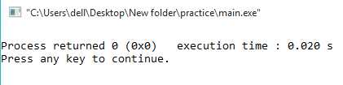

**13.2 Write a program that retrieves all the data from the text file “name.txt”**

**SOURCE CODE**

#include <iostream>

#include <fstream>

#include <string>

using namespace std;

int main ()

{

string line;

ifstream file ("NewFile.txt");

if (file.is_open())

{

while ( file.good() )

{

getline (file,line);

cout<< line <<endl;

}

file.close();

cout<<"file ended \n";

}

else

cout<<"Unable to open file";

return 0;

}

**OUTPUT**

